Introduction
If any of you are any good at your respective jobs then sooner or later you will be placed in a position of leadership. I am sure that many of you are already in such positions formal or informal. What’s certain, in my experience at least, is that it’s rare that you will have received any practical development for such a role.

Some of you are probably doing MBA’s in the hope that you will learn leadership skills - one thing for sure is that you will learn how to do good case studies. But leadership is more than reviewing cases.

It’s easy to be overwhelmed by the sheer volume of information on the field of leadership. Just do a Google search on leadership skills and you will get up to 70 plus pages of sites. Go to Google Scholar and do the same search and you will get over 100 pages of journal articles with 10 articles per page – that’s 10,000 articles.

Approximately 40% of all articles published in the field of organisational psychology are on the subject of leadership, and remember that these are scholarly articles. Then you have the plethora of books on the subject, another 100 plus pages on Amazon!

So where to begin? Well where else but with a cooking show - Jamie Oliver to be precise. His break out series “The Naked Chef” focused on simplifying the act of cooking and making it easy to produce great food. In the show Jamie set about stripping cooking down to its bare essentials; hence the term naked. Jamie would remove the complexity, simplify the process and break it down to a few steps and show how easy it was to create something delicious and healthy. No measurement just a handful of this and a pinch of that. Jamie can make cooking look easy and that’s essentially because he is a trained chef. He has learnt how to cook; he has gone to school, done an apprenticeship and trained under great chefs. He has had some great experience, coaching and mentoring. Simplicity does not mean naiveté. It helps if you have experience, guidance and support.

After having interviewed 41 of the 56 Nobel Laureates living in the USA at the time of the study, Scientific Elite: Nobel Laureates in the United States Harriet Zuckerman, Professor of Sociology at Columbia University, identified a common characteristic that they shared. They were able to see simplicity where others saw complexity. Simplicity does not mean naiveté.

Having worked in the field of organisational behaviour for the last 30 years we can say that developing leadership or learning how to become an effective leader is not a complicated thing. In fact it might sound a bit simplistic but takes less brainwork than legwork to become an effective leader. You can improve your leadership ability by focusing on a few critical behavioural skills that will make the major difference to your performance and benefit both the business and the people around you.

Leadership what it is.
How do you know if you have any leadership potential? How would you spot a leader if you saw one and what could you do to develop your own leadership potential?

The good news is that while there is a vast ocean of information on the subject of leadership there is a fair consensus as to what skills are required for effective leadership.

If you take the work of Ram Charan for example – currently one of management consulting’s prominent thinkers he certainly believes that leadership can be taught – and by the way so do I.

According to Charan leaders need to possess two major attributes: people acumen – the ability to mobilise others to accomplish a vision, goal, task or a project; and business acumen - that is an understanding of how the business makes money.

Our focus is on the first of these attributes – people acumen and how to maximise your potential as a leader. Business acumen is what most people get instruction in, how to read a balance sheet, how to create a business plan, and in MBA programs, it’s what a lot of the instruction and team work is based around.

It’s the hard stuff – how to manage and lead people – that few of us get any real practical experience or training in. Even then we are lucky if we have any good coaching in it or find any good role models. Many young mangers get experience in leadership via projects. Yet even in leading projects there seems to be a scarcity of formal leadership support.

This issue has been highlighted by The Project Management Institute. In September of 2009 Project Management Institute’s chapter in Melbourne Australia led with this in their newsletter:

“Business now demands a new breed of Project Manager........to achieve this, organisations must embed behavioural attributes into their Project Management recruitment”.

What do they mean by “behavioural attributes?” They are obviously talking about people acumen but what specifically?

If we refer back to Charan he states that leaders primarily need to possess the ability to communicate effectively – all aspects of communication. They need to be able to communicate their vision; they need to be good listeners and be constructive and articulate and they need the ability to influence others.

Let’s look at some global research conducted by the Gallup organisation on the subject of employee engagement – this is what people on the receiving end of leadership are looking for:
- I know what is expected of me at work.
- I have the materials and equipment I need to do my work right.
- At work, I have the opportunity to do what I do best every day.
- In the last seven days, I have received recognition or praise for doing good work.
- My supervisor, or someone at work, seems to care about me as a person.
- There is someone at work who encourages my development.
- In the last six months, someone at work has talked to me about my progress.
- At work, my opinions seem to count.
- The mission/purpose of my company makes me feel my job is important.
- My fellow employees are committed to doing quality work.
- I have a best friend at work.
- This last year, I have had opportunities at work to learn and grow.

At least half of the items listed above are directly affected by the actions of leaders within an organisation: creating purpose or meaning, caring about others, discussions about progress, encouraging development, listening and providing recognition, and in the majority they involve some form of social interaction.

In developing people acumen there what I believe to be a couple key skills that will make the most difference. The good news is that these skills can all be learnt. The two skills I want to focus on are Management By Walking Around (MBWA) and giving reinforcement.

Management by Walking Around
The first skill I will focus on is the skill of walking – or Management By Walking Around to be precise. The legwork I mentioned above.

In a world of social networking I don’t believe you can lead via Facebook or twitter even though it might suit your personality type or make you feel as though you are being efficient by saving time. This is not time well saved. Being present and available for your employees to reach out to and to meet, face to face, is incredibly powerful and its effects cannot be underestimated, and not only in the good times but perhaps more importantly when times are tough.

You will get no clearer example of what I mean than looking two recent catastrophic events: the bush fires in Victoria Australia that cost over 170 lives and destroyed over 1 million acres of property, and the BP oil rig disaster in the Gulf of Mexico almost 20 times greater than the Exxon Valdez oil spill and regarded as "worst environmental disaster the US has faced" by White House energy adviser Carol Browner.

In both these examples people in the most senior of leadership positions Christine Nixon the Victorian Commissioner of Police and Tony Hayward CEO of BP respectively, were lambasted from pillar to post for being absent at critical times. Nixon for going out to dinner rather than being at the fire centre command and Hayward for absenting himself by going sailing off the coast of the Isle of Wight in the UK, thousands of miles away from the Gulf of Mexico.

Now I doubt whether Christine Nixon could have done any more to stop the fires or Tony Hayward could have done anything to stop the oil gushing out of the Deep See Horizon Oil Well, but what ultimately destroyed their reputations, was the lack of their presence at critical important moments.

Compare that to the performance of Rudolf Giuliani during the September 11 New York Twin Tower terrorist attacks. He was visible and clearly present during the unfolding disaster. He can be seen walking through the streets of New York with police and fire brigade personnel instructing people to “leave southern Manhattan” and dealing with the media in real time as the disaster was unfolding.

In and article entitled “In 9/11 Chaos, Giuliani Forged a Lasting Image” published in The New York Times in 2007, there is clearly praise and acknowledgement for what he did during the unfolding disaster and after it. Un be known to many people Giuliani was also in danger of being killed when the first tower collapsed as the command centre he was in was directly next to the first tower.

In all organisations there are critical important moments – maybe not for you but certainly for the people who work for you, your peers and your customers. And the way you get access to these moments is to get out of you office or away from your desk.

Simply put MBWA (management by walking around) means that you get out of your office or workspace and walk around the place, making sure you make meaningful contact with people as you do.

Increasing contact with people does a very important thing: It allows people to get to know you and people prefer to say yes to individuals they know and this increases your chance of influencing them in the future.

Ram Charan rates the ability to influence as a key leadership skill. Your efforts at MBWA need to be planned because if not done well it can backfire. There are many examples of how not to do MBWA well; all you have to do is watch episodes of the popular TV series The Office.
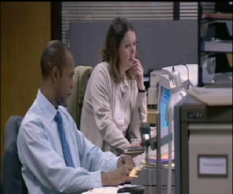

But in order to do it well there is a simple recipe for MBWA success:
- Plan when you will do it.
- Plan where you will do it.
- Plan how long you will do it for.
- Listen.

When to do it - there are two components of this: first what time in the day you will do it; and second when in the week you will do it.

You don’t need to do MBWA every day but you certainly need to plan when you are going to do it. It doesn’t have to be the same day in the week or same time, it can vary. In fact you can even skip a week or days so long as you don’t stop the activity all together. Your employees need to know that sooner or later you will see them. This requires planning on your part, and with most modern office calendars it should be possible for you to block out times during the day and week when you will not be available for meetings. These are the times when you will be doing your MBWA. One tip is to be careful what time of the day to do it. Don’t do it at the end of the day when people are about to leave because they will think you are just checking up on them!

Plan where you will go – the mistake that is often made by not planning where you will go is that, as creatures of habit, we go to those people who we like and forget about the others. It’s easy to do because it’s part of our nature to go where we get reinforced for going. But it’s not good enough if you want the opportunity to influence others. You need to cover a good cross section of the work force. I coached a manager who had people in four different geographical locations and he scheduled time in the week to go to all four. One of the locations was interstate.
Plan how long you will do it for - To be successful at MBWA you have to have time to actually stop and have meaningful conversations with people – this is not “California smile training” after all. People can sense insincerity a mile
away as highlighted in this video.

If you rush around from one person to the next only engaging in superficial conversation you will not be perceived as sincere. You need time to inquire as to how people are; you need time to have genuine conversations with people, and you need to turn your cell phone off when you are listening.

Listen - Listening can be hard work (I actually teach managers how to listen and get into rapport with people). It is a skill few people think of developing. It is such a routine, everyday activity that most people give it little or no thought. Yet it can have a tremendous impact on success in your personal and business life.

Listening can be more tiring than talking. It demands intellectual, even emotional, effort. It’s draining and tiring because; unlike hearing it demands total concentration. Consider the basic communications model of sender and receiver. Originally developed as a model of electronic communication the Shannon Weaver Model provides an excellent framework for understanding human communication.
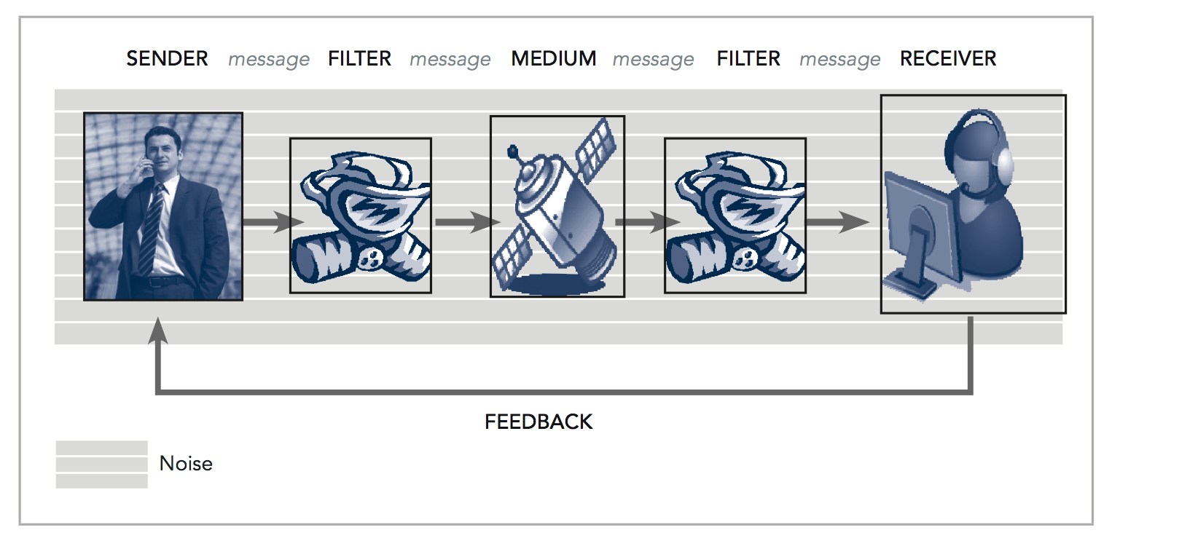
Communication requires a source – a speaker that has some information to transmit – a message. The speaker translates the information into a code that represents the meaning of what they wish to transmit. Encoding occurs via a filter. This filter represents the speaker’s mental perceptions, vocal mechanisms, muscles, gestures and so on. The message travels via some medium and is decoded at the receivers end through the receiver’s filter. All of this happens in an environment where there is noise – any interference which may affect the clarity and meaning of the transmitted message. A feedback mechanism provides information as to the effectiveness of your communication.
Ultimately the most effective communication is one where there is “high bandwidth” and in two-way communication that means face to face. Not only are the words transmitted, but everything that goes along with the words such as gestures, facial expressions, emphasis, tone, etc. No smiley emoticons from an SMS or Facebook.
Now think about your business – when are the critical times you can make your presence felt? Coming in on weekends because you have to hit critical milestones? Staying back late because team members are working back?

Gold Stamp Production Example
In 2000 Australia Post introduced the instant stamp featuring Australian Olympic gold medal winners. It was a crude process that was based on photocopying images placing them on stamps and selling them at the Olympic Village in Sydney by midday the following day after an Australian Gold Medal. The next Olympics would be held in Athens Greece, and Australia Post needed a process to create instant overnight stamps for sale in Australia the following day after an Australian Olympic victory.

In 2004 Australia Post introduced the overnight gold medal stamp. Logistically it was a much more complex process than the one used in 2000, involving having the photo taken and uploaded to the USA at Getty images who have the rights to the image, having a design shop work on the image to make it into a stamp, getting it approved by the AOC (Australian Olympic Committee) in Athens and then getting the finalised stamp to the stamp manufacturers who produce it and out to the Australia Post network by 5am the following day.

The stamp production team and their manager streamlined the process, they mapped out all the steps required for getting a stamp designed, made and distributed to the Australia post network of post offices within the short time frame they had.

The manager played a pivotal role in dealing with the complexities of working with the IOC and AOC officials, officials of the various sporting bodies, athletes, their managers, photographers etc. She also played a key role in keeping up the morale and the spirit of the design team and production teams who were working overnight to get the stamps out.

She could have stayed at home and let the process run its course but she didn’t. She went to the design studios and the production facilities in the middle of the night. Bought food for the team members and was on hand to deal with problems both local and at the Olympics.

The Australian Broadcasting Commission even made a documentary about it. This was a team that had also been in training for the Olympics. They had literally put the stopwatch on themselves and timed every part of the approvals and print process and kept driving for faster times via improvements. This was only possible because their leader provided the environment and support for them to do so.

Like a good coach, she understood the power of her presence at this critical time and very high profile time for the business and her people and was physically there during the late nights and early hours of the morning.

Reinforcement
The second key characteristic is reinforcement. Reinforcement can be described as praise, recognition, anything that makes the person receiving it feel they are valued.

It can be delivered via an extrinsic force – someone telling you “you have done a good job”, or it can be experienced intrinsically – where you feel good about yourself because you have accomplished a challenging task or a goal you set for yourself for example.

In some situations the act of giving and receiving reinforcement is natural and expected. For example: In sporting situations players receive reinforcement - from other players (peers), coaches and supporters when they have done a good job. There are multiple and frequent reinforcement opportunities and sources present in sport.

Reinforcement is immediate at the time they have completed the good play, kicking a goal, stopping an opponent or shortly afterwards - quarter time or completion of the game. Importantly all teams celebrate and acknowledge each other. Celebration is a part of sport.
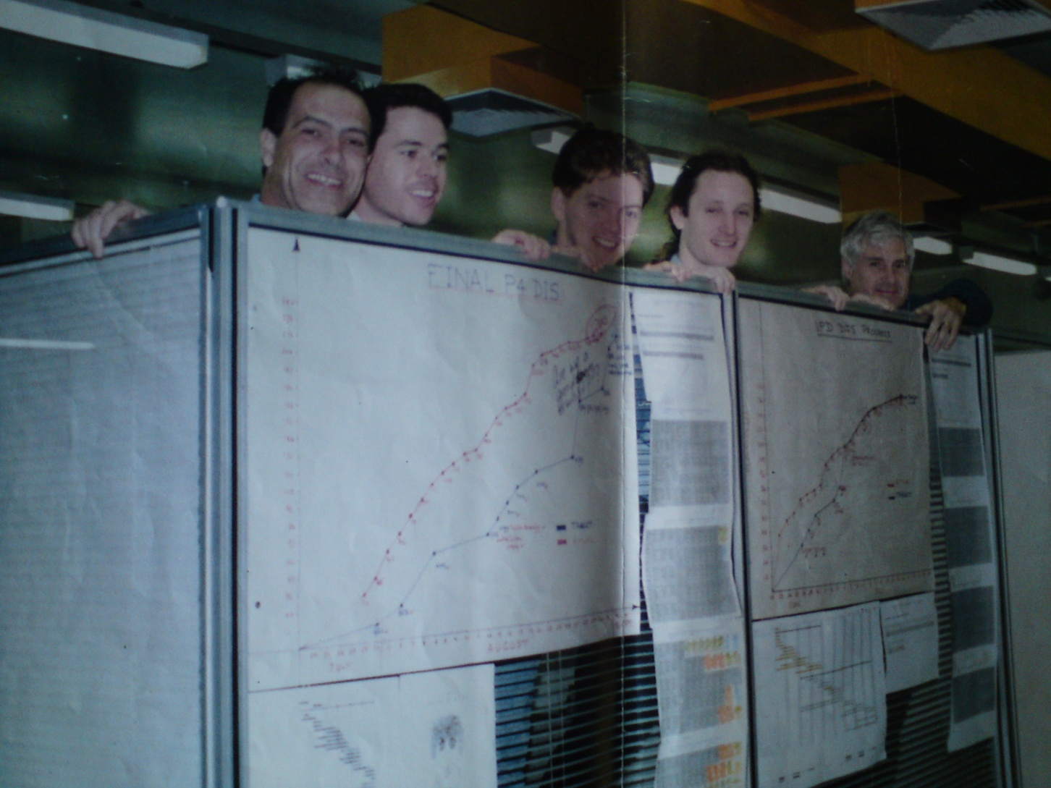
Have a look at this picture and what do you see? A happy project team, and they are happy for a very good reason – they came in on time, on budget and in fact ahead of schedule. If you look closely you can see that on the wall near their workspace they had lots of charts with writing on them, which they used to monitor their progress. They monitored their progress on a daily basis and could tell whether they were on track, or not. In fact the whole company knew and the writing on the graphs is from their work colleagues giving them praise. Sounds hokey but it’s true and it’s in Australia.

When was the last time you saw a project team doing high fives? Quite often no celebration occurs - individuals just move to the next project. When was the last time your boss came around and gave you praise for good work and when was the last time you gave a peer praise for their good work?

Yet we know from experience and research that reinforcement is a central component in maximising performance.

One of the most widely used and popular models for understanding team formation and development is Tuckman’s Team Development Model. Originally developed in the 1960’s and then modified in the 1970’s to add the Adjourning phase, the model characterises the stages that people go through when they are placed in teams (the model was originally developed as a result of research conducted with submariners in the US navy).
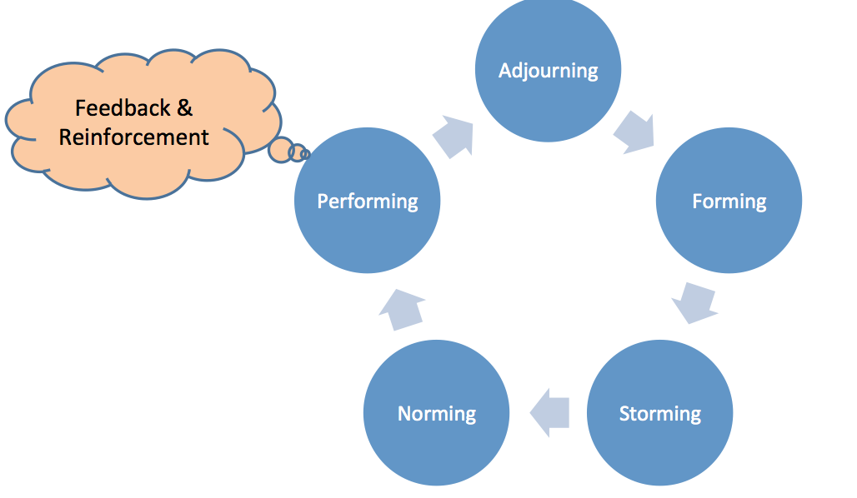
The stage that all teams need to reach is known as the performing stage. That’s where goals are achieved. But do we know what happens in this stage? You only get performing if you get feedback and reinforcement. Feedback is information that the performer or performers can use to modify their performance whereas reinforcement is praise and or acknowledgement that the performer receives from accomplishing a goal or task.

One thing you can do is to build feedback and reinforcement into to every project or into your regular MBWA planning. We instruct project teams to adopt a team agenda, which ensures that opportunities for reinforcement are built in. Do this enough times and you will find that you are starting to change the culture of the place ...and you will notice the improvement in performance.

Just like MBWA you can learn when and how to give positive reinforcement. It needs to be honest. As mentioned above people can tell if you are being sincere or not. You must be sincere and honest when giving reinforcement. Reinforcement should also be immediate if possible (don’t wait too long after the event to give it otherwise the person/people wont remember what they have done to merit it). Make sure you make your reinforcement personal (given in a way the person appreciates). Some people like praise that is public, others do not, and they may prefer something more private. Find out what the recipient of your reinforcement appreciates and tailor to suit them. Finally ensure that your reinforcement is specific – tell them what they have done that you really appreciate, they will have a greater chance of repeating the performance in the future.

How to plan for success - The Checklist
There one simple tool you can use that will revolutionise the way you lead, and its called the checklist! It might seem contrite to mention but checklists are critical in many high risk jobs from flying aircraft to intensive care units in hospitals.

As mentioned above we have had great success working with CEO’s in improving their leadership performance by simply having them use a checklist that they keep in their shirt pocket or on their desk as a constant reminder.

The checklist acts as a prompt to get out and practice MBWA and it acts as a prompt to make sure you are giving someone positive reinforcement. One useful tip is to use a small notepad for your checklist. It also helps you record bits of information; especially helpful if you need to get back to someone with a response to a question you couldn’t handle at the face-to-face meeting. Simply get your notebook out, jot the info down and tell them you ‘ll get back to them.

Now maybe there is an apple I Phone app that will allow you to do it or maybe you can do it on a blackberry but sometimes the old ways work faster.

CONCLUSION

Performance can be significantly improved if you understand and use the basic skills of making your presence felt via listening, managing by walking around, being present in times of need or crisis and reinforcing others. While we call them basic skills they are often overlooked or not planned for. Making time in your diary for these activities and scheduling them is one of the most simplest and effective means you have available.

To paraphrase a recent posting in the Harvard business review made by Stanford Professor of Management Robert Sutton:

“Every generation of leaders thinks it's facing a new set of challenges that require drastically new models of leadership. Certainly today's leaders work in a very different environment, but being an effective manager is not about mastering mysterious and complicated methods. It's about keeping it simple and following old, proven, and even obvious ideas.

What made a good leader in the past is still what makes one today: being competent, caring, and benevolent.

Before you discard this old model in exchange for the latest reinvention of management, take a close look at the method. Often times it's the same message in a new package.”

